Q370 – Interactive Activation Model Lab

Open http://www.psychology.nottingham.ac.uk/staff/wvh/jiam/

Click the link: Click here to start jIAM

Click Create Model

1.  Click on the Settings button.

1. Looking at the row of default values for Feature-to-Letter parameters, what does the ratio of excitation to inhibition tell you about how feature nodes influence the activation of letter nodes?
   1. **By default, the values are as follows:**

***Feature to Letter Excitation: 0.005***

***Feature to Letter Inhibition: -0.15***

**These values show that when a feature is presented, it can excite a letter a little bit. But a letter’s activation node is more inhibited by a contradictory feature that the letter does not have. The ratio is**

**-0.033333333 which means that a feature has a more inhibitory relationship to the letter layer then an excitatory relationship.**

1. In this model, what are false positive responses and how might this ratio be changed to create more false positives?  When might this happen in everyday life?
   1. **False positives are defined as scenarios where when presented with a particular feature, the node that corresponds to a contradictory letter is activated. To create more of these false positives, the ratio of excitation to inhibition would need to be positive rather than negative. This can be changed by setting excitation to a negative value OR setting inhibition to a positive value.**

1. For a word perception task using this model, which parameters feed information forward? Backward?
   1. **Forward:**
      1. **Letter to Word Excitation**
      2. **Letter to Word Inhibition**
   2. **Backward:** 
      1. **Word to Letter Excitation**

1. What layers can inhibit letter features?  What reasonable connections (list and explain 2 possibilities) might be added to this list of parameters to add additional inhibition to features?
   1. **Layers that inhibit letter features:**
      1. **The model currently, there are no layers that inhibit letter features. But this does not follow the interactive activation model that was proposed by McClelland and Rumelhart.**
      2. **Two reasonable connections would be to add inhibitory connections from words to features and between feature nodes themselves. This would fall more in line with the interactive activation model.**

2. Click Back to return to the main view.  The '_' character indicates an unknown letter (no features present).  Run a simulation with the default parameters for 10 cycles with the word '_alt'. Afterward, click Nodes to get a printout of node activation over time. Alternatively, select the layer (e.g. letters or words) and set (i.e. letter position) you’re interested in.

1. Which letters become active for the 2 (pos_1), 3 (pos_2) and 4th (pos_3) letters?  Why?
   1. **pos_1: A**
   2. **pos_2: L**
   3. **pos_3: T**
   4. **These are all activated because they are the letters presented at each position. As the cycle number increases, the activation for each node increases.**

1. Which letters have any activation for the first letter?  Which letters are more active than others?  Why would this be the case given that there are no features present to influence the first letter?
   1. **B, C, E, F, H, L, P, S, T, V, and W are all activated to some extent within the 10 cycles. This excitation is caused by the word to letter excitation pathway that is present within the model. By presenting a word (or in this case a partial word), we can excite multiple nodes representing possible letters.**

1. Draw a rough sketch of the pertinent nodes within the model (include short, written annotations) that demonstrates why W has much less activation than H for the first letter.

**Because there is no “Walt” word and there is a word “Halt” the activation for the “H” node is greater due to the word superiority effect.**

d) Switch to the graph of word activations.  What word nodes have the most activation after 10 cycles?  Why might that be?

**“Salt” and “Halt” have the highest activations because they are words. Their status gives them superiority in their activation over non-words like “Walt” or “Zalt.”**

3. The '*' character is defined in this model to be an ambiguous set of features between an R and a K.

a) Sketch how this ambiguous character might look in the simple feature set used in the model (you might want to use Figure 4 from McClelland & Rumelhart (1981) as a base)

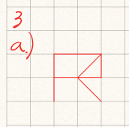

b) Set Layer to Letters and letter Position to 0 and conduct simulations with ‘*ize,’ '*eel,’ *ide' and '*ick'.  The model knows the words “reel,” “ride,” “kick,” “keel”, but does not have “kize,” “rize,” “rick” or “kide” in its dictionary. Explain the disparity between K and R activations in the first letter slot across the four simulations.

**Depending on what words were found within the dictionary of the model, we would find the activation for the corresponding letter in pos_0 for the letter that shares the most features with the word that’s in the dictionary. For instance, “kick” is in the dictionary of the model where “Rick” is not. Because the * character is shared between r and k, the model relies on the correlation between the * character and its knowledge of the word “kick” to activate the k node.**

c) Look at the graph generated for “*ick” over 20 cycles.  What is the final activation of R for Letter position 0 (the first position)? You can click the Nodes button to see accurate activation values.  Does this seem consistent with your understanding of McClelland and Rumelhart's model description?  Why?  What parameter value(s) would need to be added or changed for the final activation of R to be around or below 0, and why did you add/change this parameter?

**The final activation level for R is 0.3638. This is consistent with my understanding of the model. Like what I mentioned before, the * shares some features with R so some activation is to be expected. But, having “Kick” in the dictionary of the model causes it to be a greater activation for the letter “K” due to the shared features of * and the word superiority effect.**

**To change this activation, we would need to have some inhibition from the word to the letter. Currently, the model has excitation but not inhibition. This would mean the activation of “Kick” would have some negative value attached to the activation of R in the model.**

d) Consider the input '*i_e'.  Run the simulation for 20 cycles.  Sketch and explain a small network that demonstrates why there was a difference for ‘k’ and ‘r’ activations in the first letter position.

**There is a greater activation for R than K in the first position because although the * character is in the first position, which gives activation towards moth characters, there are more words within the models dictionary that match the input and include R in the first position.**

4. The default value for word-to-word inhibition is -0.21 in this model.  Consider variations of this and sketch each resulting graph:

a) When the value of word-to-word inhibition is reduced to -0.01, run '_ick' for 20 cycles and look at the graph of Words.  What about the words in the two groups separates them into two distinct groups?  Why are so many words partially active at the end of 20 cycles?

**The two groups are created by the matched pattern of _ick where _ is any letter in the alphabet that has a corresponding word where ick is appended. All other words are partially activated due to the lack of inhibition but, the other inhibitory factors eventually deactivate those word nodes.**

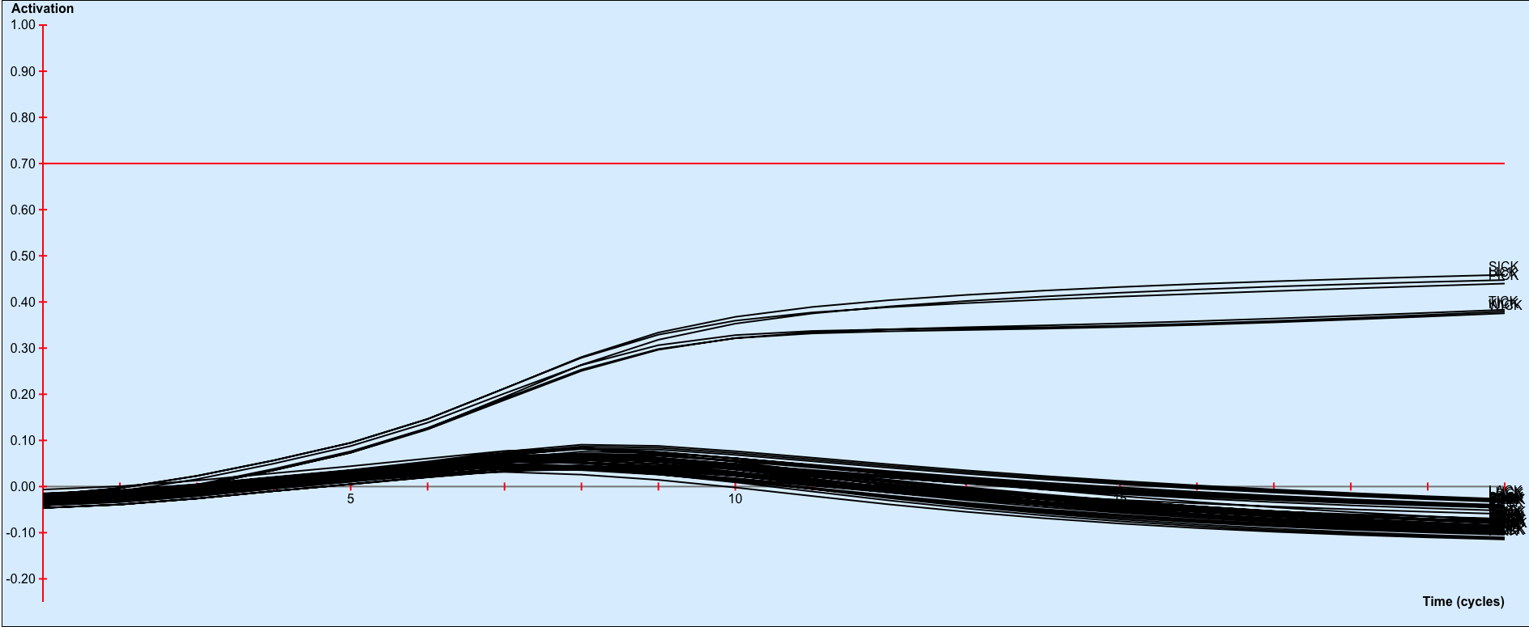

b) Increase word-to-word inhibition to -0.3 and run the model again. How does this change the graph?  Why?

**Because some words are initially activated with a certain value, they beat down the rest of the competition through lateral inhibition regardless of the fact if the nodes for a given word match the input.**

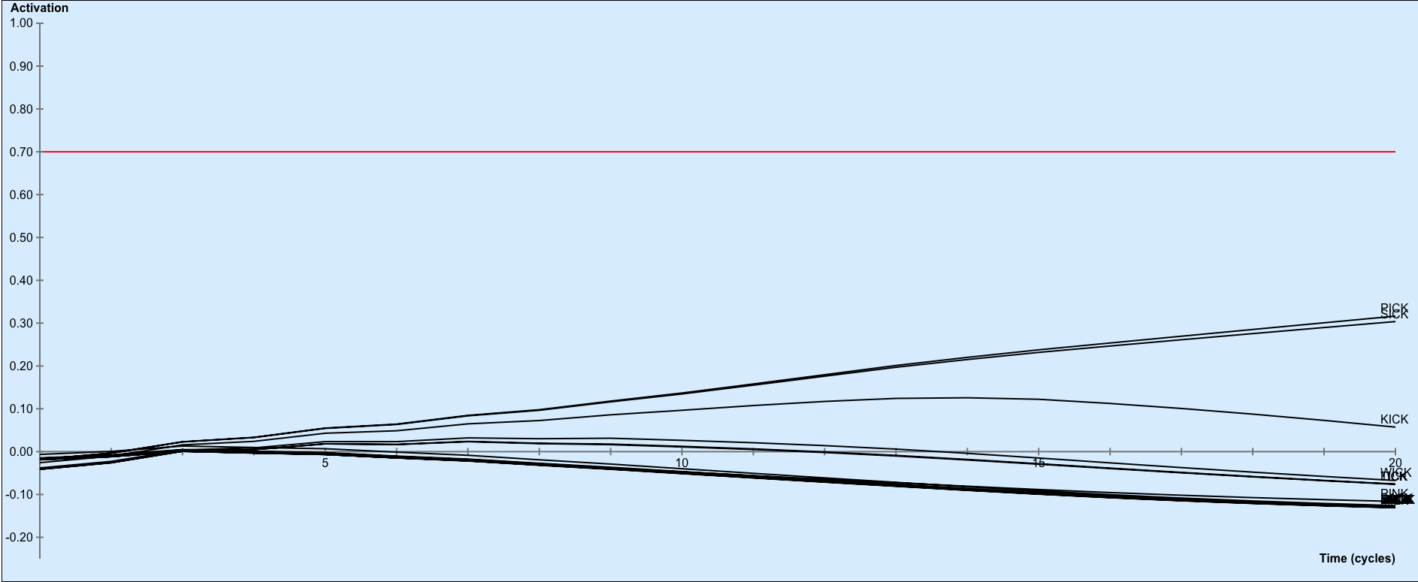

c) Increase the word-to-word inhibition to -0.7.  Give an explanation of what might have happened at around 12 cycles that produces this effect.

**At around 12 cycles, I believe that the activation for “pick” is great enough to cause the activation of “sick” to depreciate due to lateral inhibition. Similar to my answer to the above question, a winner is chosen by having their activation greater initially, when the inhibitory factor is great enough, that initial winner will continue to appreciate while all other nodes that match the stimuli will depreciate in activation. Chart, line chart
**

5. In a few typed paragraphs, relate the concepts of bottom-up and top-down processing to the way this model works.  How does the cascaded and interactive process of the model differ from a standard information processing model in which earlier stages, when they complete their processing, send their outputs to the next stages.

**This model works through a cascaded and interactive process, which means that nodes have excitatory and inhibitory relationships to one another as well as nodes above and below them in the model’s topography. For instance, letters are connected to words and vice versa. There is also lateral inhibition between words and other words. Through top-down processing, we know that words can have a relationship with letters and thus by proxy features. As a bottom-up approach, features can excite or inhibit letters, which by proxy can excite or inhibit words.**

**This unique topology defers from the typical structure of a model with a standard information process because of this nonlinear transfer of information. In something like a perceptron, information is processed between nodes and backpropagation does not take place. But, because every node is interconnected and weights moving in opposite directions are present in this model, we see a topology that catalyzes a cascaded and interactive relationship between nodes.**